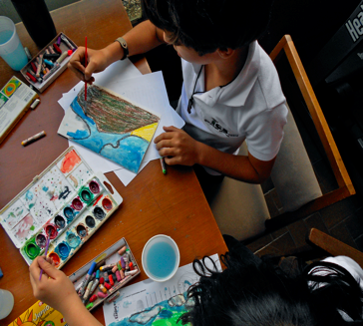
Art Integration
When thinking about integrating arts in the curriculum or classroom in a meaningful way, it might seem daunting or intimidating to some teachers. Some may think that in order to teach art, one must be an artst. What about prep time? In an interview with EDS faculty Caren Holtzman, she talked about her journey as an elementary teacher in discovering how there was a distinct overlap in the same skills needed for learning math was also present in skills needed for art. She noticed there was a mismatch of how math is traditionally taught (structured/single-product oriented). Whereas after speaking to her teaching artist colleague, the process of doing art is more open ended in very skillful ways. Some skills correlation between math and art are strategizing, planning, taking risks and trying new methods or options.
So, Holtzman started integrating art in her math lessons. She started from her comfort zone and found many entranceways into the arts through math. She found that art could help her as a teacher learn her students’ thinking process, make learning more meaningful for them and give insight into what sort of choices her students were making. “Art serves as a purpose and an audience,” she said, “as opposed to a quiz.” Art integration is important for many reasons. This exploration displays the many ways how art integration provides new ways for teachers and students in assessing and accessing.

As Merryle Goldberg, Ed.D. stated in her book Arts Integration: Teaching Subject Matter through the Arts in Multicultural Settings, arts integration is learning through the arts. (xvi) By the arts one typically means an individual or collective expression using a creative format that displays one’s thinking. This could be facilitated in traditional formats such as painting, poetry, acting, dancing and sculpting. In this article, art does not necessarily mean the traditional sense, but could also mean any sort of creative expression in order to show one’s thinking.

What is Art Integration?

For teachers

Why is art integration important?

Contents:

Research Overview 1-2

Qualitative Study 3

Findings & Recommendations 3

References 4

How does the integration of art provide fresh avenues of access and assessment for students & teachers?
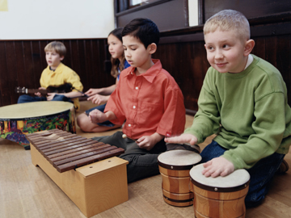
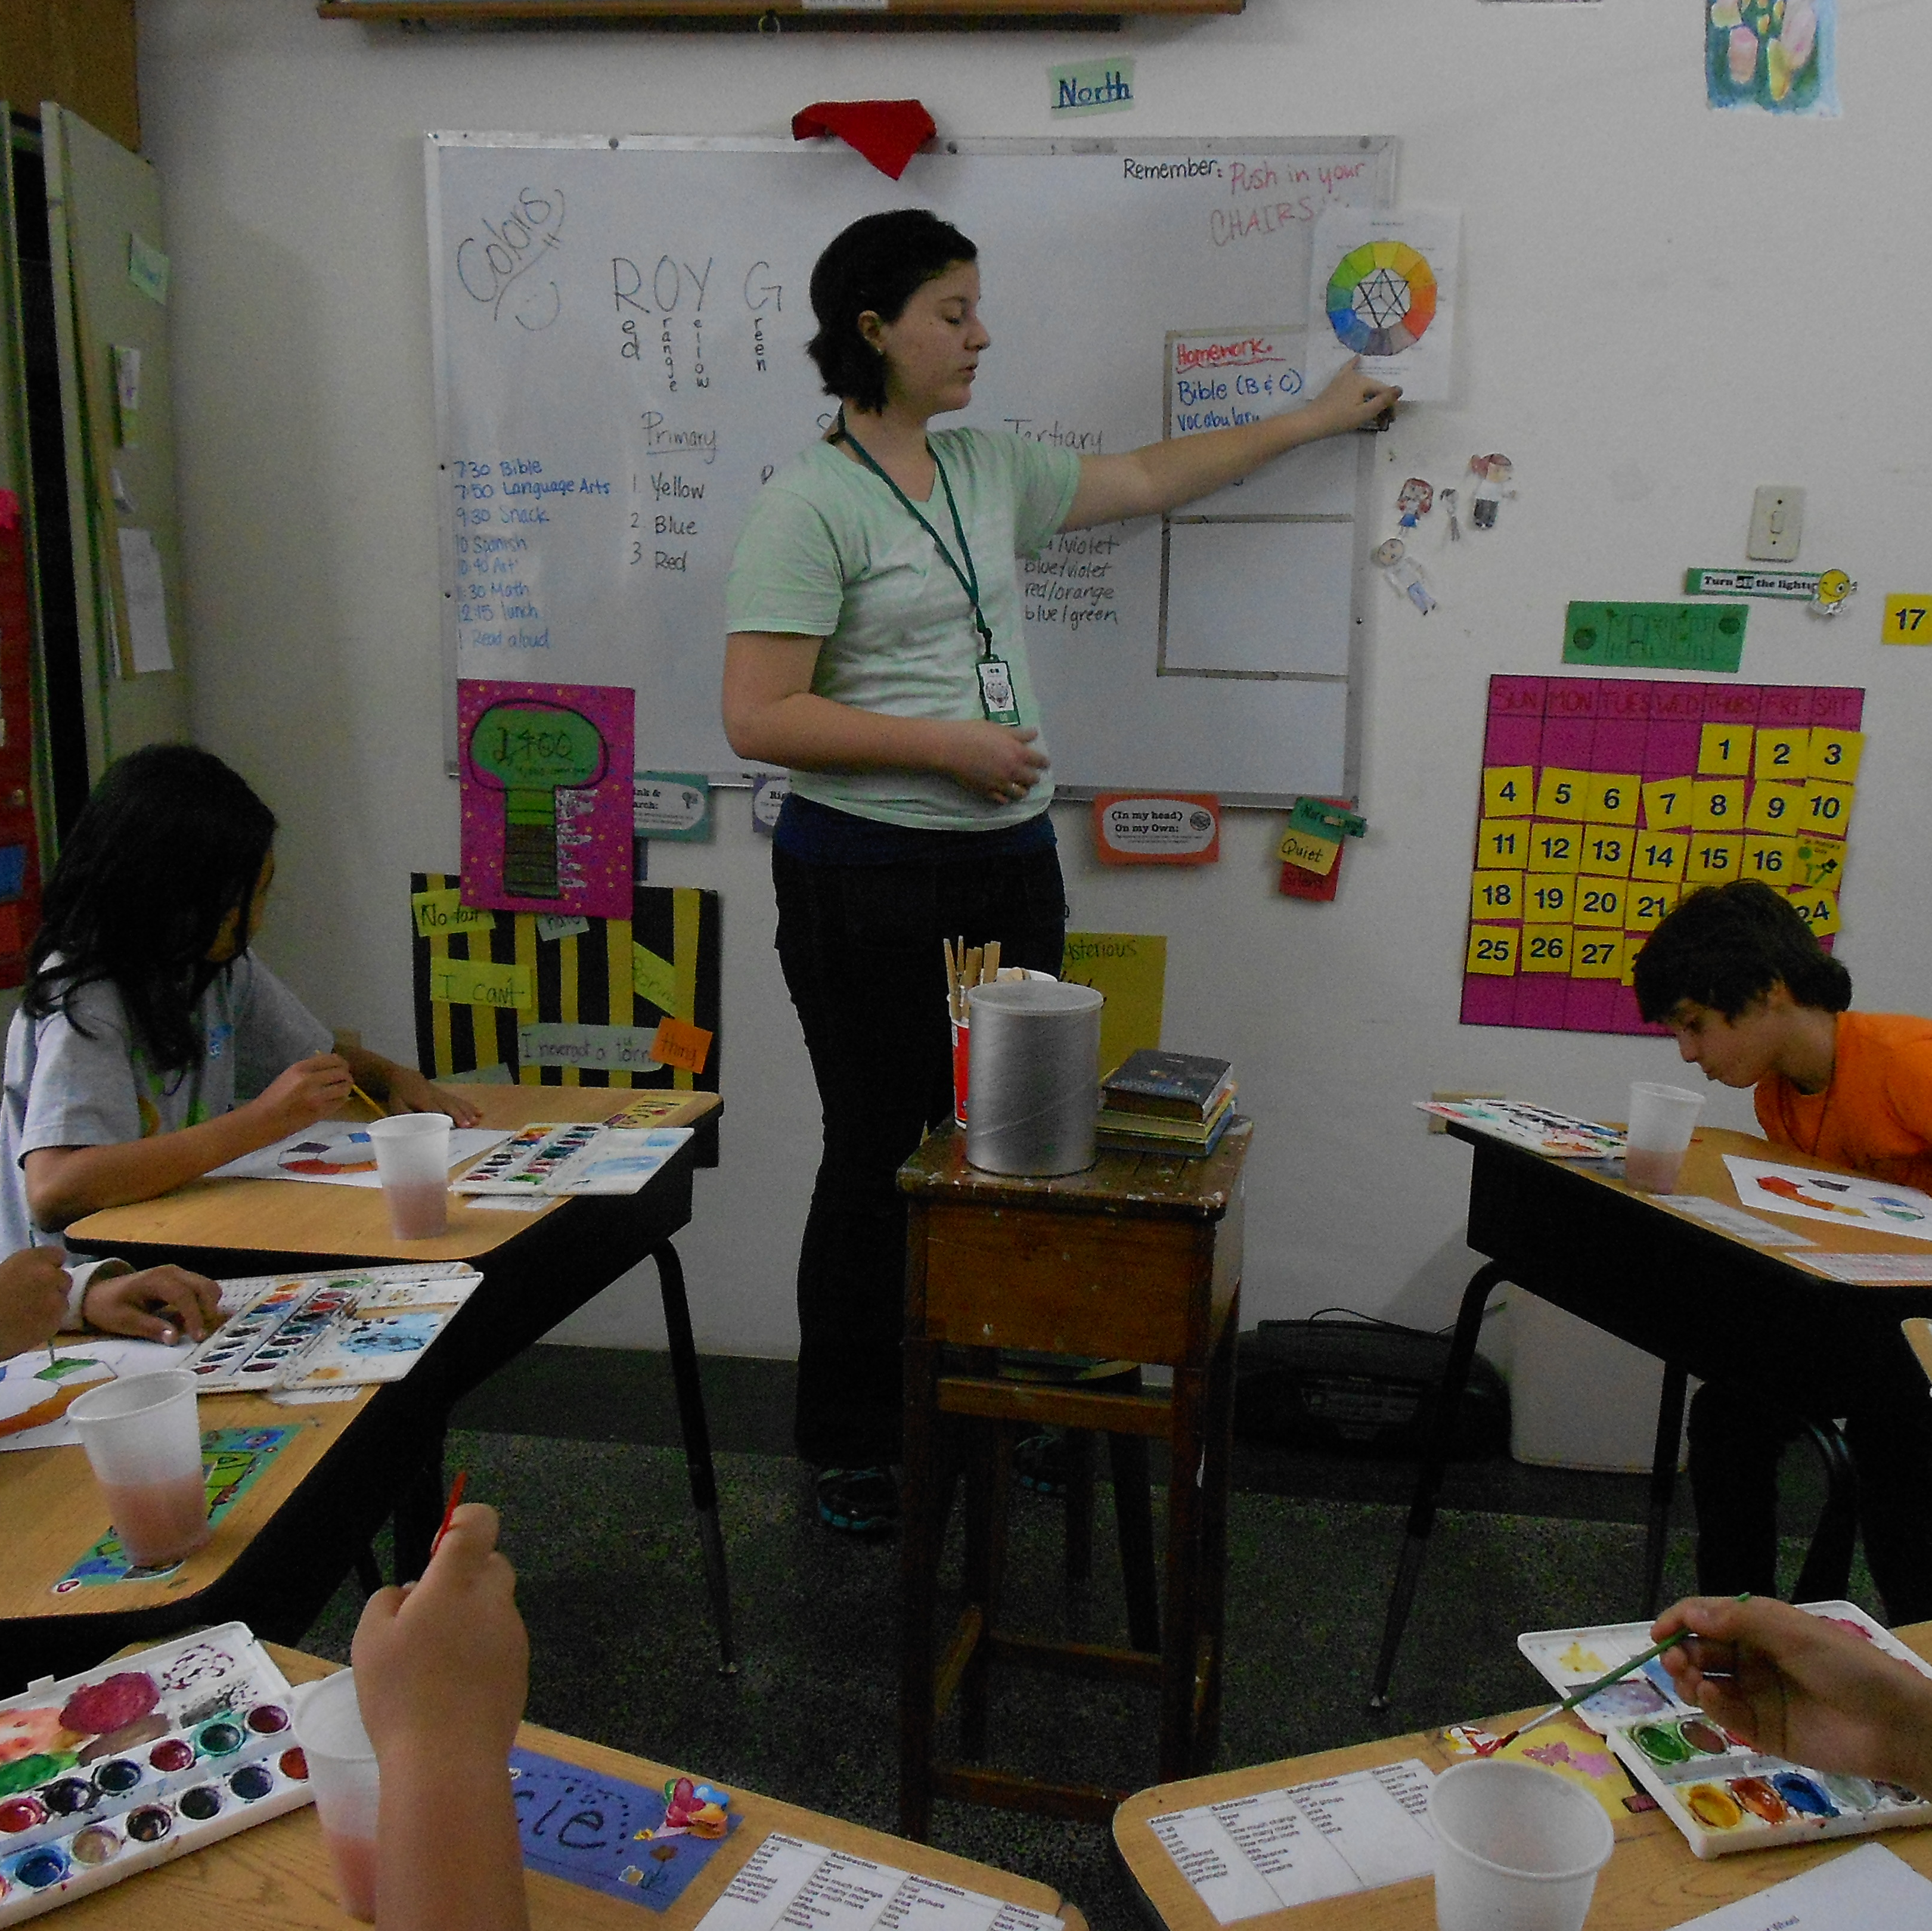
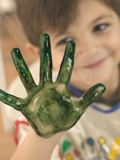
Common Core
As discussed in a recent study, the uniqueness of how art can be a key connection for various disciplines to interface helping schools transition to Common Core. (Marshall, 2014) Now that many states are shifting from the previous No Child Left Behind, which focused more on an intense amount of time in reading and focusing on testing, there is a shift in what is needed and expected to be successful in the classroom. There is a focus on practicing skills needed to make students career and college ready.
In an online article addressing the importance of art integration with today’s shift into new standards, the following skills were listed which they noted are important skills in art as well as Common Core. Some of these skills include “creativity, problem-solving, perseverance, collaboration and the ability to work through the rigorous demands of multiple ideas and concepts woven together to create a final product”. (Riley, 2012) Art integration focuses on the process, contains many different “access points”, reaches many different learners, and allows for a lot of practice in analyzing which are all present in today’s Common Core Standards. (Riley, 2012)

Student Access
Studies have proven that when a school allows for the integration of arts, more learning takes place. In a 2 year focus-group project with teachers across the United States who either teach the arts or integrate the arts in their curriculum with students with special needs, researchers found 3 main skills that their students strengthen as a result of their arts-based curriculum. One of the three that is highlighted is the fact that students can have equal access to the curriculum when learning the arts because they noticed that art made learning fun and enjoyable. (Mason, et.al., 2008)
Curriculum is more accessible when students feel successful while learning. In an action research study where 5 elementary teachers were interviewed for their point of view on teaching arts integrated various subjects such as Math, Social Studies and Language Arts. The main conclusion found in this qualitative study was that Arts integration allows “students to shine at the level that is needed for them to shine”. (Scott et.al., 2008)
In a study comparing two 4th grade classrooms in low socio-economic areas, one class that integrates art and another that does not, they found that there are many benefits including rising of test scores. “The best arts integration programs are developing a strategy- that is helping to close the achievement gap even those in the poorest communities.” (Rabkin & Redmond, 2006)

Arts integration –which brings to teaching & learning the benefits of artistic thinking, process, and creativity – could be a major player in this new paradigm.
-Marshall, (2014)

Student’s artwork provides a rich arena for assessing their understandings. [It] documents students’ world of contemplation & exploration.
-Goldberg (2012)

We recommend integrating the Arts into every classroom no matter what the content or grade level. When done appropriately, {These} activities are a great way to get students actively involved in their learning .
-Kosky & Curtis (2008)

If poetry can be that vehicle for connecting skills, concepts, and information across the science curriculum, we owe it to children to infuse poetry wherever we can.
-Vardell & Wong (2014)

Teachers....
I find a lot of power in using art as an assessment. I can give a student a multiple-choice quiz on area and perimeter or I can have them demonstrate their knowledge through creating it. Both get the same information, but art produces engagement, excitement and enduring understandings that will be greater...” -3rd grade teacher

Art integration is vital! We integrated art in first grade by introducing famous artists & genres when studying countries.
-1st grade teacher(Harper & Baggon, 2012)

The sad truth..

I overheard one of my 2nd graders tell their friend to not color or illustrate their story because they might get in trouble....kids here are not used to doing art in this school.

-2nd grade teacher

Q: If there was more art in your school, how do you think it would help you as a student? I think it would be a fun thing to do and if teachers do not have anything else to teach, we could do art.” - 2nd grader

Research...

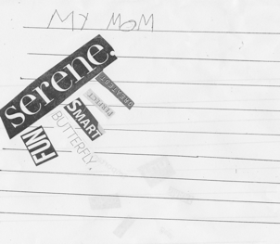
Qualitative Study
Several interviews were performed at public schools in southeast San Diego in low socio economic communities as well as high amounts of English Language Learners. Four 2nd graders and 4 teachers at one of those schools were interviewed came from a school that does not place an emphasis of art integration. 2 elementary teachers were interviewed from a school that provides teacher training in arts integration (STEAM).
Both schools were chosen in order to explore the differences and similarities in perceptions and attitude regarding art integration in the classroom. Arts-friendly suggests an atmosphere that provides & encourages avenues for teachers to integrate arts in various subjects with training and support.
In addition to interviews, a 2nd grade class observation was done . This class came from a school that is more traditional and has had limited amount of art exposure. The class was composed of the majority of English Language Learners and 25 children in total.
Methodology
Some interviews were performed one-on-one and recorded. Other interviews were executed in a group setting. All questions were performed conversation-style so as to allow the interview take certain directions in a natural way.
In order to see how students with little to no arts integration in their education respond to such activities, an extension lesson focusing on adjectives and poetry in a 2nd grade classroom in Southeast San Diego was done. After preparing the students by utilizing partner shares, visualizing and think-alouds, they were directed to sift through some magazine cut outs of adjectives at their tables. They carefully chose 5-6 words to describe their mothers and arranged the words on their papers in an interesting way.
While they chose their 5-6 words and arranged them on paper, teachers circulated the room to each table and asked them questions such as “Why did you choose this/these particular words” or “Why did you arrange your words like this?” Such open ended questions allowed a better understand of their thinking process and logic.

Findings:
Many themes were uncovered in the interviews & observation. They were the following:
Each teacher interviewed acknowledged the importance of art integration or art education. Some linked it to critical thinking skills and problem solving.
Each child interviewed, from the traditional school, acknowledged that there needs to be more art in their school yet they were not clear as to why it is important other than it is fun.
Both educators, that came from districts and schools that encouraged art integration, did not have a strong arts background but was in an environment that provided training and/or allowed for collaboration with teaching artists.
Students showed engagement and were on task during the activity and were able to express their thinking.
Many ELL students were able to show her thinking in a very unique and creative way through the poetry activity.
2nd grade class displayed thoughtfulness in their decisions while choosing their words.

Recommendations....
Start small. You do not have to be an artist to teach it.

Get involved in a think tank or professional development group to be inspired by other teachers striving to do the same thing. STEAM is a great way to start!

My mom likes to take showers. This is why I put the words this way. (shower head)
-- Maya, 2nd grade, ELL

References
Goldberg, M. (2012). Arts integration: teaching subject matter through the arts in multicultural
settings (4th ed.). San Marcos, CA: California State University, San Marcos.
Marshall, J. (2014). Transdisciplinarity and art integration: Toward a new understanding of art-
based learning across curriculum. Studies in Art Education, 55(2), 104-127.

Kosky, C., & Curtis, R. (2008). An Action Research Exploration Integrating Student Choice and

Arts Activities in a Sixth Grade Social Studies Classroom. Journal Of Social Studies Research, 32(1), 22-27.

Rabkin, N., & Redmond, R. (2006). The Arts Make a Difference. Educational Leadership, 63(5), 60-64.
Riley, S. (2012, November 30). Use arts integration to enhance common core. Retrieved from
http://www.edutopia.org/blog/core-practices-arts-integration-susan-riley.

Scott, L., Harper, S., & Boggan, M. (2012). Promotion of Arts Integration to build Social and

Academic Development. National Teacher Education Journal, 5(2), 83-88.

Mason, C., Steedly, K., & Thormann, M. (2008). Impact of Arts Integration on Voice, Choice, and

Access. Teacher Education & Special Education, 31(1), 36-46.

Vardell, S., & Wong, J. S. (2014). Observe, Explain, Connect. Science & Children, 51(8), 31-35.

Written by:
Deborah Obregon
EDS 206
July 2014

